

**ASEPSIS**

**(SMART DUSTBIN MONITORING SYSTEM**

**WITH SENSORS AND ARDUINO)**

**SUBMITTED TO:**

Dr. DURGANSH SHARMA  
Assistant Professor (SS) Department Of Computer Application

**SUBMITTED BY-:**

|  |  |  |  |
| --- | --- | --- | --- |
| **COURSE** | **Name** | **Sap ID** | **Enroll NO.** |
| **BCA** | **HIMANSHU JAISWAL** | **500066529** | **R174218017** |
| **BCA** | **VAIBHAV MISHRA** | **500066709** | **R174218064** |
| **BCA** | **SPARSH AGARWAL** | **500069350** | **R174218091** |
| **BCA** | **ROHAN VIJAY** | **500071423** | **R174218079** |

**INDEX**

* Agile Manifesto.................................................2
* Introduction.......................................................3
* Outcome............................................................5
* Entity Relation Diagram...................................6
* Data Flow Diagram...........................................7

**AGILE MANIFESTO**

The following 12 Principles are based on the [Agile Manifesto](https://www.agilealliance.org/agile101/the-agile-manifesto/).

1. Our highest priority is to satisfy the customer through early and continuous delivery of valuable software.

2. Welcome changing requirements, even late in development. Agile processes harness change for the customer’s competitive advantage.

3. Deliver working software frequently, from a couple of weeks to a couple of months, with a preference to the shorter timescale.

4. Business people and developers must work together daily throughout the project.

5. Build projects around motivated individuals. Give them the environment and support they need, and trust them to get the job done.

6. The most efficient and effective method of conveying information to and within a development team is face-to-face conversation.

7. Working software is the primary measure of progress.

8. Agile processes promote sustainable development. The sponsors, developers, and users should be able to maintain a constant pace indefinitely.

9. Continuous attention to technical excellence and good design enhances agility.

10. Simplicity–the art of maximizing the amount of work not done–is essential.

11. The best architectures, requirements, and designs emerge from self-organizing teams.

12. At regular intervals, the team reflects on how to become more effective, then tunes and adjusts its behaviour accordingly.

**INTRODUCTION**

With the advancement in technology people are much more dependent on materialism. Use of materialistic things are common with people in their daily lives use of products like paper, plastic, vegetables peels etc are common litter, in order to collect these waste materials dustbins are used . But people are not careful enough and still they litter here and there, with these disease are likely to spread which can be epidemic

This article exhibits a Smart Solid Waste Monitoring and gathering framework. It is a typical sight to witness trash spilled out in and around the residue containers. The region around an inappropriately looked after residue receptacles can house illness spreading creepy crawlies like mosquitoes, flies, honey bees and driver ants. The earth around a dustbin is likewise favorable for expanding the contamination level in air. Air contamination because of a dustbin can create microscopic organisms and infection which can deliver life undermining infections in individuals. Extra consideration must be taken in a thickly populated region where the squander stores in the containers are adequately high.

Dustbin level is transmitted through server with the help of Ultrasonic sensor. At a time we can screen the dustbin all through the system. It implies we can get to the information from dustbin where all the work stations are associated with a similar system.

At regular intervals the information about the degree of trash in the dustbin is refreshed. After the dustbin is filled totally it is shipped by a vehicle to the landfill yard to keep the city clean. This plan is free of Worldwide System for Mobile Communication (GSM) what's more, consequently can be utilized in condos, ventures what's more, clinics.

The remainder of the article is composed as follows: Section 2 shows a short review on existing residue checking frameworks. Area 3 presents the square portrayal of the brilliant residue container observing framework;

Segment 4 spotlights on the equipment usage, while end and degree for future work are given in Section 5 and 6 separately.

**OUTCOME**

**Advantages:**

* In our framework if dustbin is moved to another migration it will consequently enlisted with the server with the new GPS area.
* It will save fuel and time using appropriate route planning.
* Keeps the environment clean and fresh.
* Reduces environmental pollution.
* Empowering ‘Swatch Bharat Abhiyaan’.
* Real time based cleaning of our locality, streets, cities etc.
* It makes our system transparent between the Municipal Corporation, workers and public.

**Disadvantages:**

* Garbage separation is difficult.
* The process is not always cheap.

**Future Scope:**

* The project is just a demo and is likely to be taken at product level.
* It can be made durable, by making it compact and cheap.
* Two bins can be placed in order to collect wet and dry waste, thus garbage separation problem can be overcomed.
* Wet waste can be decayed to produce biogas.

**Entity Relation Diagram**

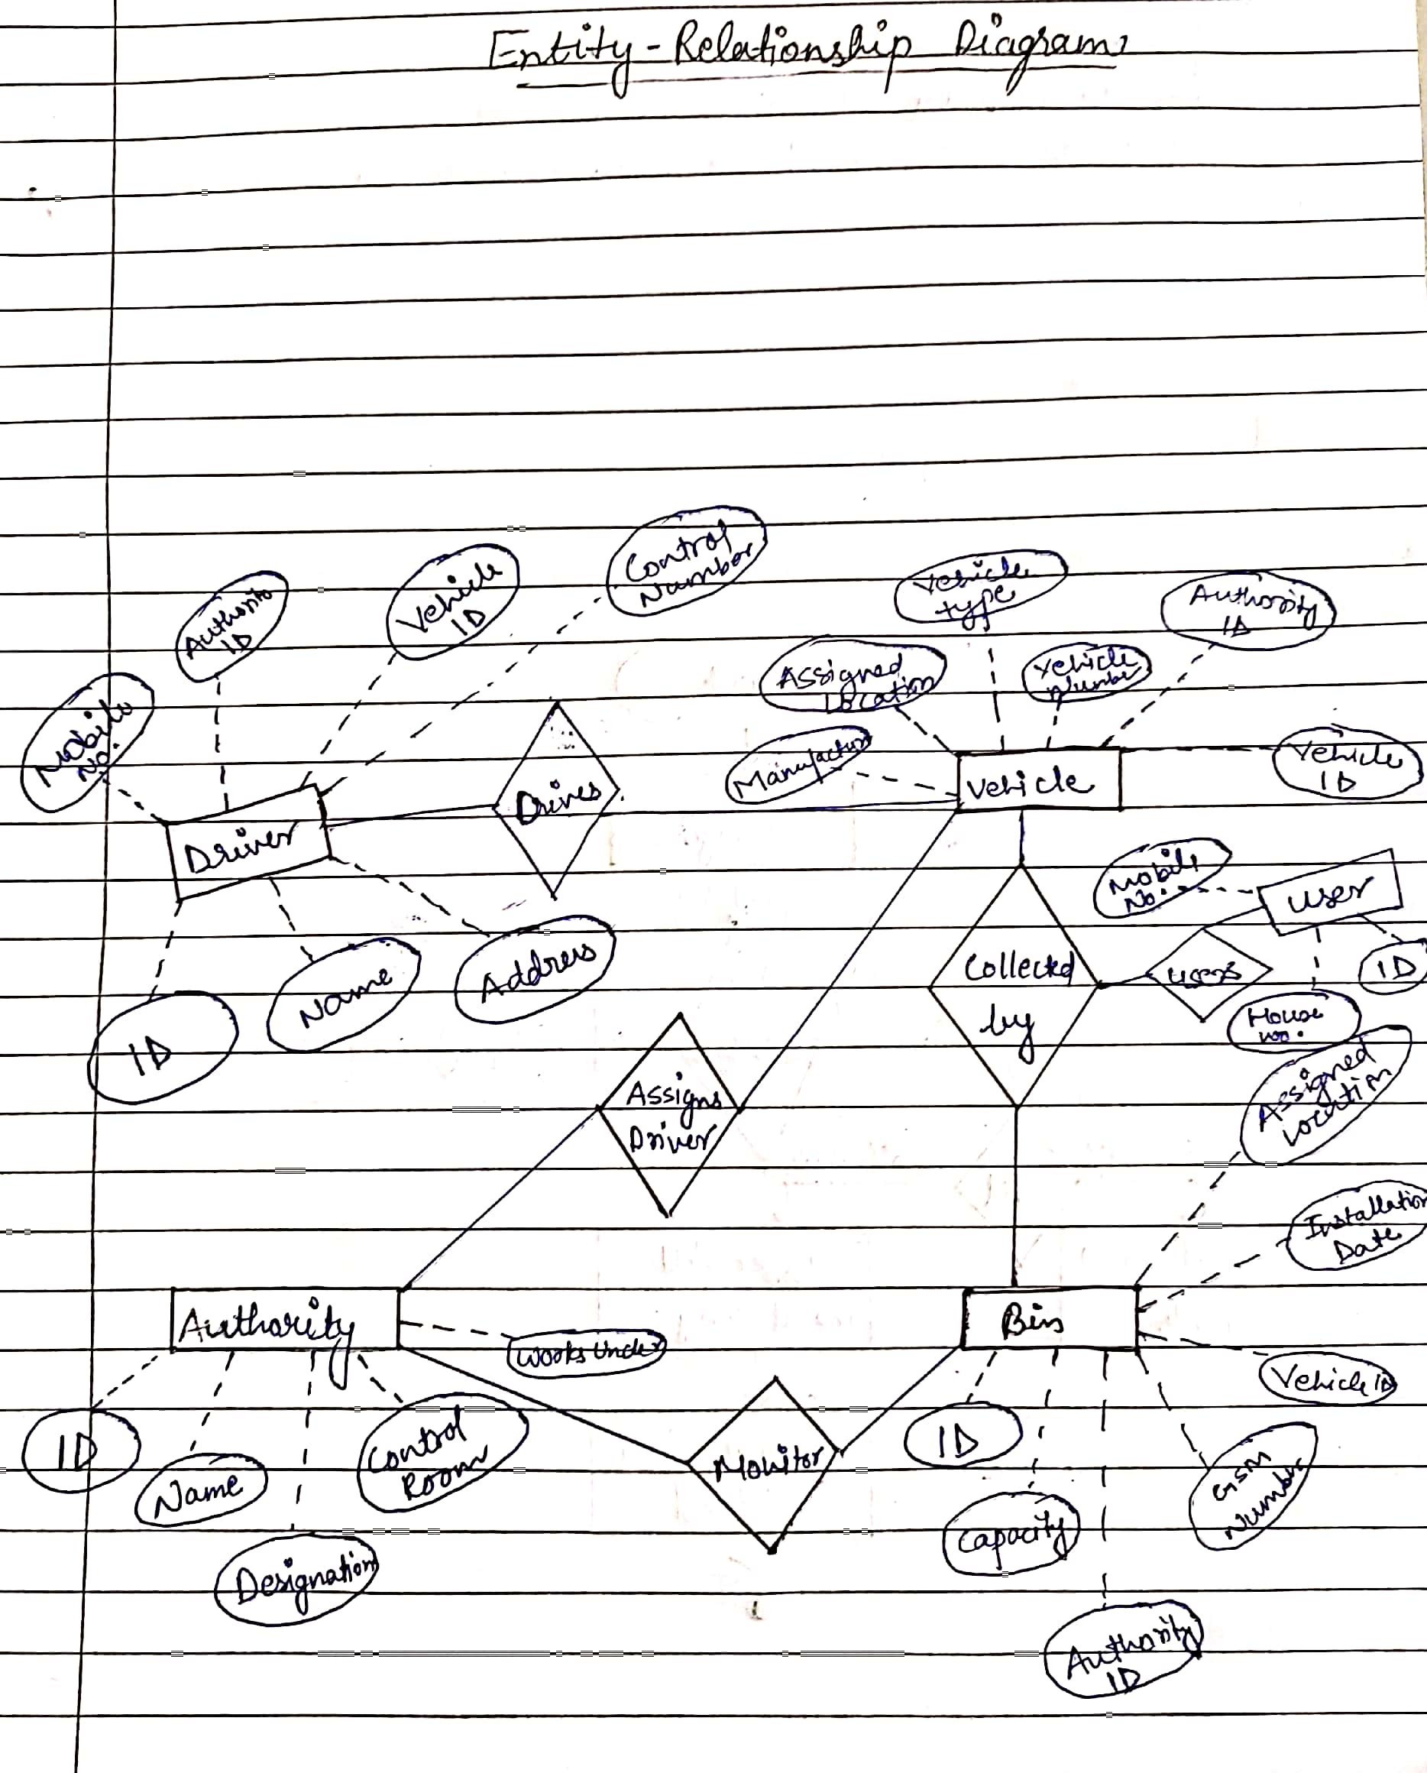

**Data Flow Diagram**

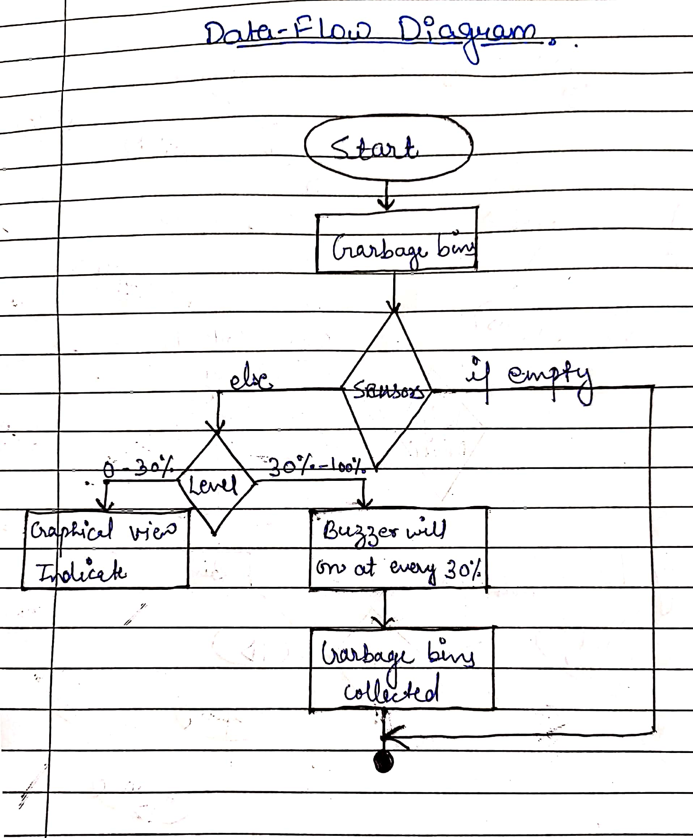

**References**

* International Journal of Advances in Computer and Electronics Engineering, Vol. 2, April 2017, PP.20-23
* https://docplayer.net/99164088-Smart-trash-can-monitoring-system-using-iot-creating-solutions-for-smart-cities.html